AS level Chemistry: a general outline!

CIE AS Level Chemistry can be a challenging course, but with the right strategies and dedication, you can achieve a good grade. This guide is only an outline of what I did to achieve a good grade in the course, but how you study effectively may be different. If so, I recommend that you experiment with the techniques below, and gauge how *you* respond.

**I. Understanding the Syllabus:**

Familiarize yourself with the CIE AS Level Chemistry syllabus:

<https://www.cambridgeinternational.org/Images/554616-2022-2024-syllabus.pdf>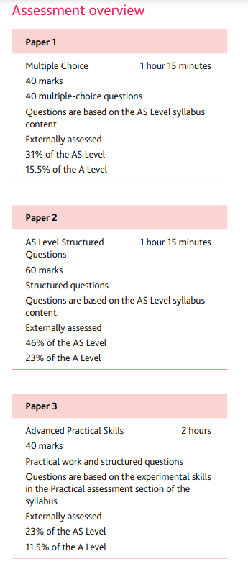

**Paper 1:** The paper is math heavy, and is considered generally as above average in difficulty. Biggest difference that helped me was doing past papers from 2018-2022. Time yourself and write annotations of *what* you did wrong and *why* the answer is incorrect (and why another is correct) on the past paper itself!

**Paper 2:** The examiners want fully detailed answers. Frame your answers into points, since that’s how they grade the answers (but in written prose) Biggest difference: look at the mark scheme any time you do a past paper! They offer invaluable definitions and spell out what to add in your answers, and what’s ok to be omitted.

**Paper 3:** Detail is everything! Every line, every metric, every point on a graph has weight. Sloppiness is the enemy, and your ruler the hero! Biggest difference: learn how to draw a correct table and create a table of all the ppt reactions that are typically found in the paper. Paper 3’s mainly (from what I gathered) focused on applying techniques you have to memorize, so use active memorization techniques like the ones below.

**II. Effective Study Habits:**

a. Create a study schedule: Plan your study time to cover all topics; WHATEVER YOU, STUDY CONSISTENTLY! You will forget little details, and those papers love their details. Study for at least 10 min everyday, or 30 min every other day. Whatever works for your schedule.

b. Use active learning techniques: Take summarized notes after reading your book, make flashcards, and engage in active recall. Some of my favorite methods of studying include:

* Pomodoro technique -> 25 min study, 5 min break
* Feynman technique -> try to explain the topic in simplified language, as if you're talking to a 5 year old. Most importantly, find gaps in your knowledge, and continue to simply as you take notes
* Summary notes in your own words-> instead of writing verbatim, critically engage with your book, and try to write what you understand after reading a section in full. This also allows you to locate your gaps in knowledge, and what you glossed over

c. Prioritize difficult topics: Allocate more time to challenging concepts. After doing past papers, you will generally have an idea of what you’re struggling on. Use the markscheme, or better yet, practice problems that actively engage with your knowledge so that you improve in difficult areas.

**IV. Mastery of Core Concepts:**

Fundamental principles: Ensure a strong grasp of key concepts in chemistry, such as chemical bonding, atomic structure, and stoichiometry. Grow your knowledge from the ground up, and see how the topics relate to one another. Instead of accepting a topic as true, question *why* it’s true.

**V. Stay Healthy:**

a. Get enough rest: Ensure you are well-rested before any exams or study sessions. Always prioritize your health. You won’t learn anything about group 2 trends or the nucleophilic addition mechanism on 2 hours of sleep.

b. Eat well: Maintain a balanced diet for energy and concentration.

c. Manage stress: Practice relaxation techniques to stay calm during the exams. Don’t panic. Easier said than done, but if you consistently revise, for even 10 min a day, your backbone of knowledge will strengthen not only your confidence but also lessen your stress.

By following this (very generalized and non-specific) outline, I am sure you have a good chance of getting a good grade in your AS level Chemistry exams, with confidence and pride walking into that Urlag Zaal. Remember to stay dedicated, organized, and focused on your goals throughout your preparation and exam periods. Good luck! Our generation had an almost 50% pass rate, so if we could do it, so can you!

Any questions? Please feel free to contact me on:

Instagram: @sxruul

E-mail: 24a_saruul.g@mongolaspiration.edu.mn